Student Performance Prediction System

Project Id: AIML-8
Name : Vaibhavi Thapliyal(Team Leader)
Class Roll Number: 76
University Roll Number : 2028897
Section and Group: Q Group 2

Name : Naina Vashishtha
Class Roll Number: 53
University Roll Number : 2028774
Section and Group: Q Group 2

Name : Samiksha Gurung
Class Roll Number:66
University Roll Number : 2028836
Section and Group: Q Group 2

TABLE OF CONTENTS
- Problem Description 3
  - Dataset Description 3
  - Flow diagram 4
- Modules for Project Implementation…………………..…………………………5
  - Modules Used 5
  - Platform Used 6
- Machine Learning model/ Searching Technique used 7
- Evaluation metrics used 8
- Results and Visualizations 9
- Conclusion and Future Scope 13
- References 14

- Problem Description
The Credit Risk Prediction System is a Python-based machine learning application developed to automate the analysis and prediction of loan default risk. It streamlines the process of collecting customer financial data, training predictive models, and generating risk insights while maintaining accuracy and efficiency.
Using core concepts of Machine Learning such as data preprocessing, feature scaling, handling class imbalance using SMOTE, classification algorithms, model evaluation, and data visualization techniques, this project reduces manual effort in assessing creditworthiness.
The system analyzes customer attributes like income, credit score, employment type, loan details, and financial history to identify potential defaulters. This helps financial institutions make informed, data-driven decisions, minimize financial risk, and improve loan approval processes.

1.1 Dataset Description

The dataset used in this project contains financial and demographic information of customers, which is used to predict whether a customer is likely to default on a loan.
It consists of 1800 records and 17 features, including both numerical and categorical variables. Each row represents an individual customer, and the target variable indicates whether the customer defaulted on a loan.
Features Description
- Age – Age of the customer
- Employment_Type – Type of employment (Salaried / Self-Employed)
- Years_of_Employment – Total years of work experience
- Annual_Income – Yearly income of the customer
- Savings_Balance – Amount of savings
- Bank_Balance – Current bank balance
- Credit_Score – Creditworthiness score of the customer
- Debt_to_Income_Ratio – Ratio of debt to income
- Existing_Loans_Count – Number of existing loans
- Loan_Amount_Requested – Loan amount requested by the customer
- Loan_Term – Duration of the loan
- Missed_Payments – Number of missed payments
- Num_of_Credit_Inquiries – Number of credit checks made
- Credit_Card_Utilization – Percentage of credit card usage
- Residence_Type – Type of residence (Owned / Rented)
- Dependents_Count – Number of dependents
- Default – Target variable (0 = No Default, 1 = Default)
Dataset Characteristics
- The dataset contains a mix of numerical and categorical features
- No missing values were initially present in the dataset
- The target variable is binary (classification problem)
- The dataset initially showed class imbalance, which was handled using SMOTE

1.2 Flow Diagram

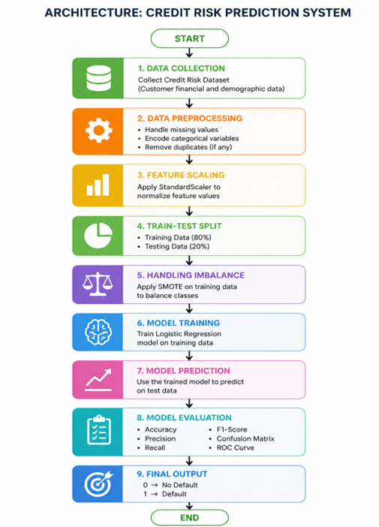

Fig.1 Sample flow diagram.

2. Modules for Project Implementation

2.1 Modules Used(mention all the inbuilt/ custom modules used and the purpose)

The following inbuilt and external Python modules were used in the implementation of the Credit Risk Prediction System. These modules helped in data handling, visualization, preprocessing, model building, and evaluation.

1. Pandas
Pandas is used for data manipulation and analysis. It provides data structures like DataFrame to handle structured data efficiently.
Functions used:
- pd.read_csv() – To load the dataset from a CSV file into a DataFrame
- df.head() – To display the first few rows of the dataset
- df.info() – To get summary information about the dataset
- df.describe() – To get statistical summary of numerical features
- df.isnull() – To check for missing values
- df.fillna() – To handle missing values (if any)
- df.value_counts() – To count occurrences of values in a column

2. NumPy
NumPy is used for numerical computations and handling arrays.
Functions used:
- np.array() – To create arrays
- np.mean() – To calculate mean values
- np.median() – To calculate median values

3. Matplotlib
Matplotlib is used for creating basic data visualizations.
Functions used:
- plt.figure() – To create a new figure
- plt.hist() – To plot histogram
- plt.xlabel() / plt.ylabel() – To label axes
- plt.title() – To add title to graph
- plt.show() – To display plots
- plt.savefig() – To save plots as images

4. Seaborn
Seaborn is used for advanced and more attractive statistical visualizations.
Functions used:
- sns.histplot() – To plot histogram with density curve
- sns.boxplot() – To detect outliers
- sns.heatmap() – To visualize correlation matrix

5. Scikit-learn
Scikit-learn is used for machine learning model building and evaluation.
Functions used:
- train_test_split() – To split dataset into training and testing sets
- LogisticRegression() – To build classification model
- fit() – To train the model
- predict() – To make predictions
- accuracy_score() – To calculate model accuracy
- classification_report() – To generate precision, recall, F1-score
- confusion_matrix() – To evaluate prediction results

6. StandardScaler (from sklearn.preprocessing)
Used for feature scaling to normalize data.
Functions used:
- fit_transform() – To scale training data
- transform() – To scale test data

7. SMOTE (from imblearn.over_sampling)
SMOTE is used to handle class imbalance by generating synthetic samples of the minority class.
Functions used:
- fit_resample() – To balance the dataset

8. LabelEncoder (from sklearn.preprocessing)
Used to convert categorical variables into numerical format.
Functions used:
- fit_transform() – To encode categorical features

2.2 Platform Used: (mention all the platforms with the reason of using it)

The following platforms were used during the development and implementation of the Credit Risk Prediction System:

1. Visual Studio Code
Visual Studio Code was used for writing, testing, and debugging the code. It provides a user-friendly interface and supports multiple programming languages.
Reason for use:
- Supports Python development efficiently
- Provides built-in debugging tools
- Offers useful extensions (like Python, Jupyter)
- Lightweight and fast performance

2. Anaconda Navigator
Anaconda Navigator was used to manage Python environments and libraries required for the project.
Reason for use:
- Easy installation of libraries like Pandas, NumPy, Scikit-learn
- Environment management for dependency control
- Simplifies package handling without manual configuration

3. Jupyter Notebook
Jupyter Notebook was used for performing Exploratory Data Analysis (EDA), preprocessing, and model building.

3. Machine Learning Model/ Searching Technique Used(Describe each ML model/ searching technique used)

In this project, a supervised machine learning approach was used to predict whether a customer will default on a loan. The following model and techniques were applied:

1. Logistic Regression
Logistic Regression is a supervised machine learning algorithm used for binary classification problems. In this project, it is used to predict whether a customer will default on a loan (1) or not (0).
The model works by calculating the probability of a data point belonging to a particular class using a sigmoid function. Based on this probability, the output is classified into either default or non-default.
Reason for using Logistic Regression:
- Suitable for binary classification problems
- Simple and easy to interpret
- Provides probability-based predictions
- Efficient for structured datasets

2. SMOTE (Synthetic Minority Oversampling Technique)
SMOTE is a data preprocessing technique used to handle class imbalance in the dataset. The dataset initially had more non-default cases compared to default cases, which could bias the model.
SMOTE generates synthetic samples of the minority class (default cases) to balance the dataset and improve model performance.
Reason for using SMOTE:
- Balances the dataset
- Improves prediction of minority class
- Prevents model bias toward majority class

3. Feature Scaling (StandardScaler)
Feature scaling is applied to normalize the data so that all features contribute equally to the model. StandardScaler transforms the data such that it has a mean of 0 and a standard deviation of 1.
Reason for using StandardScaler:
- Ensures all features are on the same scale
- Improves model convergence
- Enhances performance of Logistic Regression

4. Train-Test Split Technique
The dataset was divided into training and testing sets to evaluate the performance of the model on unseen data.
Reason for using Train-Test Split:
- Prevents overfitting
- Allows fair evaluation of the model
- Ensures generalization of results

4. Evaluation metrics used (Describe each evaluation metric used along with formulae)

To evaluate the performance of the machine learning model, several classification metrics were used. These metrics help measure how accurately the model predicts loan default and how well it handles both classes.
1. Accuracy
Accuracy measures the overall correctness of the model by calculating the ratio of correctly predicted observations to the total observations.
$$Accuracy=\frac{TP+TN}{TP+TN+FP+FN}$$
Where:
- TP = True Positives
- TN = True Negatives
- FP = False Positives
- FN = False Negatives
Explanation:
Accuracy shows how many predictions made by the model are correct out of all predictions.
Limitation:
It may not be reliable when the dataset is imbalanced.

2. Precision
Precision measures the proportion of correctly predicted positive observations out of all predicted positive observations.
$$Precision=\frac{TP}{TP+FP}$$
Explanation:
It indicates how many predicted defaulters were actually defaulters.
Importance:
Useful when false positives need to be minimized.

3. Recall
Recall measures the proportion of actual positive cases that were correctly identified by the model.
$$Recall=\frac{TP}{TP+FN}$$
Explanation:
It indicates how many actual defaulters were correctly predicted by the model.
Importance:
Very important in this project because missing a defaulter can lead to financial loss.

4. F1 Score
F1 Score is the harmonic mean of precision and recall.
$$F1=\frac{2×Precision×Recall}{Precision+Recall}$$
Explanation:
It provides a balance between precision and recall.
Importance:
Useful when both false positives and false negatives are important.

5. Confusion Matrix
A confusion matrix is a table used to evaluate the performance of a classification model by comparing actual and predicted values.
 | Predicted No | Predicted Yes
Actual No | True Negative (TN) | False Positive (FP)
Actual Yes | False Negative (FN) | True Positive (TP)
Explanation:
- True Positive: Correctly predicted defaulters
- True Negative: Correctly predicted non-defaulters
- False Positive: Incorrectly predicted default
- False Negative: Missed defaulters

5. Results and Visualizations

Fig 2:

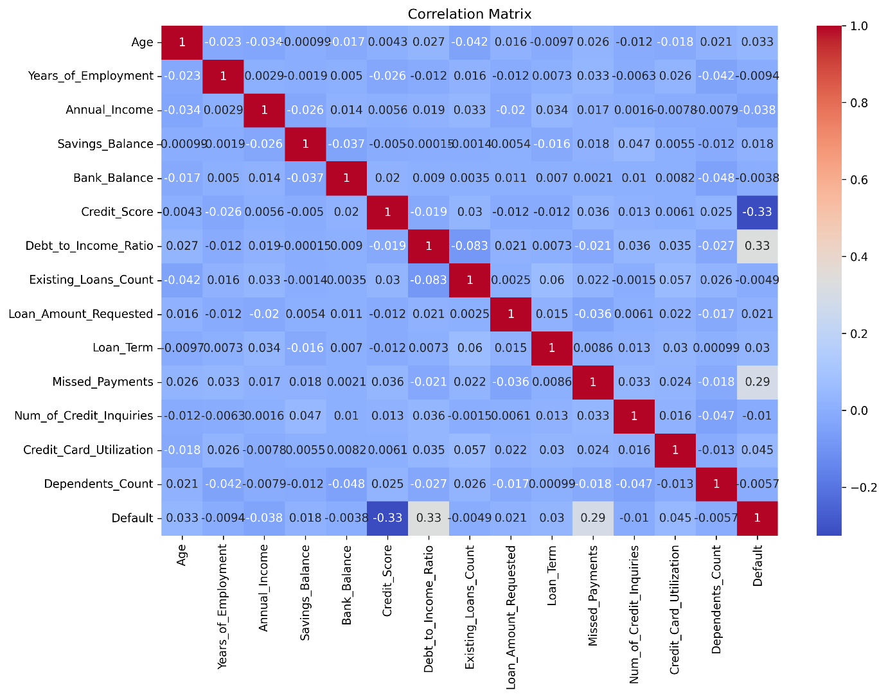

Fig 3:

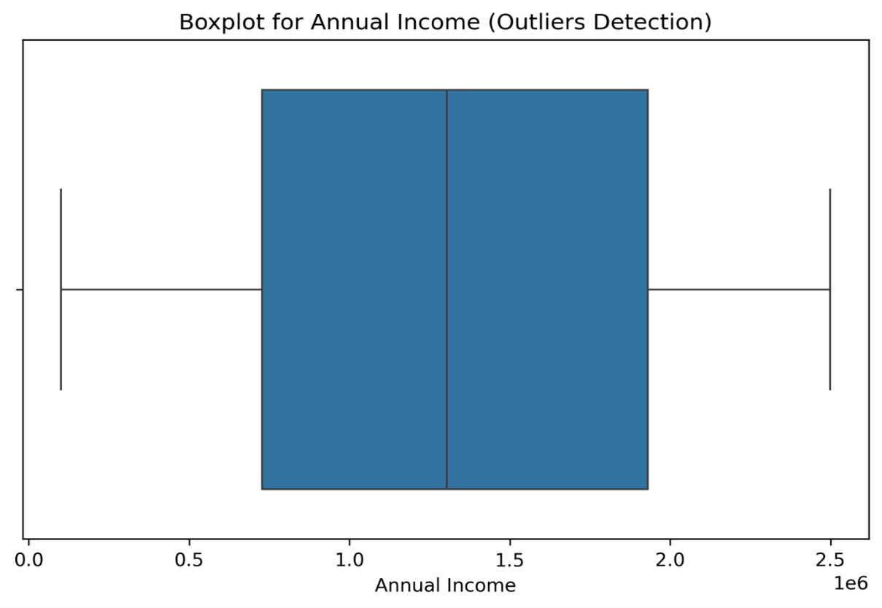

Fig 4:
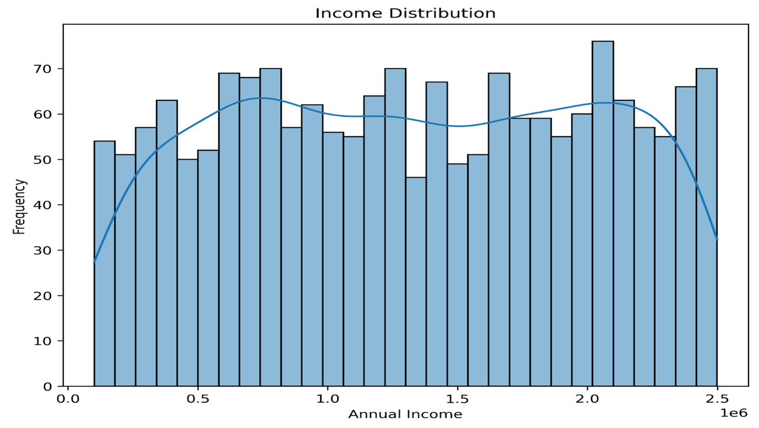

Fig 5:

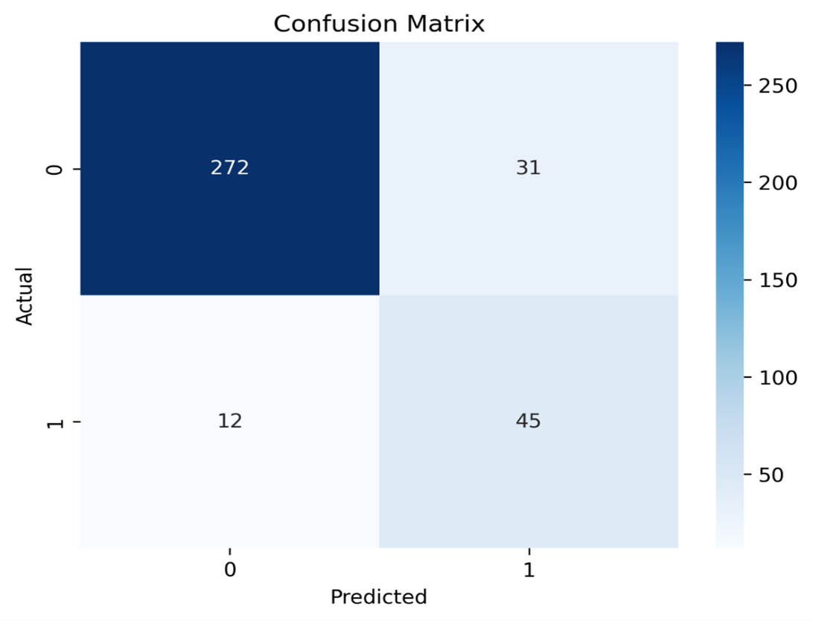

Fig 6:
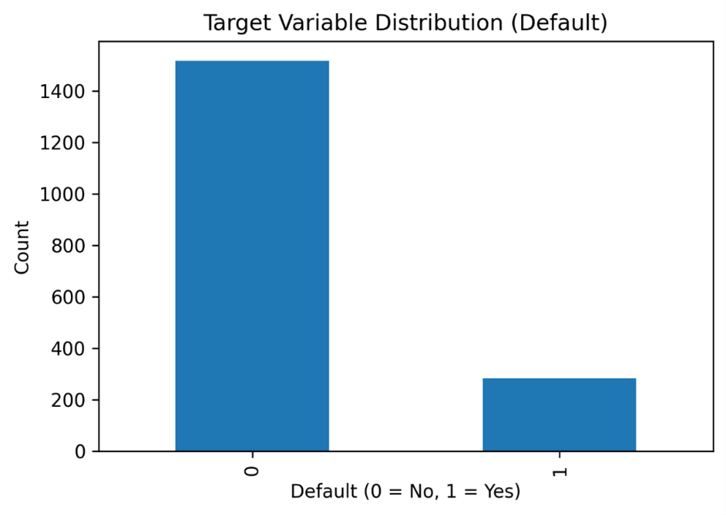

Fig 7:

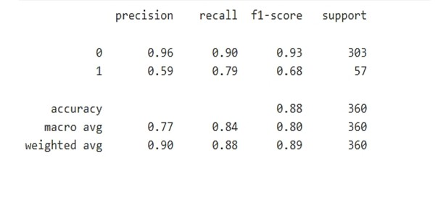

6. Conclusion and Future Scope:

Conclusion
The Credit Risk Prediction System was successfully developed using machine learning techniques to predict whether a customer is likely to default on a loan. The project involved key stages such as data preprocessing, exploratory data analysis, handling class imbalance using SMOTE, feature scaling, model building using Logistic Regression, and performance evaluation.
The results demonstrate that the model is capable of identifying patterns in customer financial data and making reliable predictions. Evaluation metrics such as accuracy, precision, recall, and F1-score indicate that the model performs effectively in classifying defaulters and non-defaulters. This system can assist financial institutions in making informed decisions, reducing financial risk, and improving loan approval processes.

Future Scope
Although the current system provides satisfactory results, several improvements can be made in the future:
- Use of Advanced Models: Implement more advanced machine learning algorithms such as Random Forest, Decision Tree, or Gradient Boosting to improve prediction accuracy.
- Hyperparameter Tuning: Optimize model parameters to enhance performance and reduce errors.
- Real-Time Prediction System: Develop a web-based or application-based interface for real-time loan risk prediction.
- Larger and Real-World Dataset: Use larger and real-world datasets to improve model generalization and reliability.
- Feature Engineering: Introduce new meaningful features to improve model performance.
- Deep Learning Integration: Explore deep learning models for more complex pattern recognition.

7. References:

Books:
- Yashavant Kanetkar, Let Us Python, BPB Publications

Online Resources:
- GeeksforGeeks – https://www.geeksforgeeks.org/
- TutorialsPoint – https://www.tutorialspoint.com/python/index.htm
- Stack Overflow – https://stackoverflow.com/

Documentation & Libraries:
- Scikit-learn Documentation – https://scikit-learn.org/
- Pandas Documentation – https://pandas.pydata.org/
- NumPy Documentation – https://numpy.org/
- Matplotlib Documentation – https://matplotlib.org/
- Seaborn Documentation – https://seaborn.pydata.org/
- Imbalanced-learn (SMOTE) Documentation – https://imbalanced-learn.org/

